BeatAssassin
AFG8500

User Manual
16-Voice Digital Drum Machine
v2.1.0

1. Getting Started
Welcome to the BeatAssassin AFG8500, a 16-voice drum machine simulator designed for your phone. When you first open the app, you will see a short boot-up animation as the synthesis engine initializes. After a few seconds, the main interface loads and you are ready to make beats.
The AFG8500 is built around three core areas: the control panel at the top, the 4x4 pad grid at the bottom, and the LCD screen that ties everything together. Let us walk through each one.

Interface Overview
The diagram below shows the full layout of the BeatAssassin. Key areas are labeled A through F.
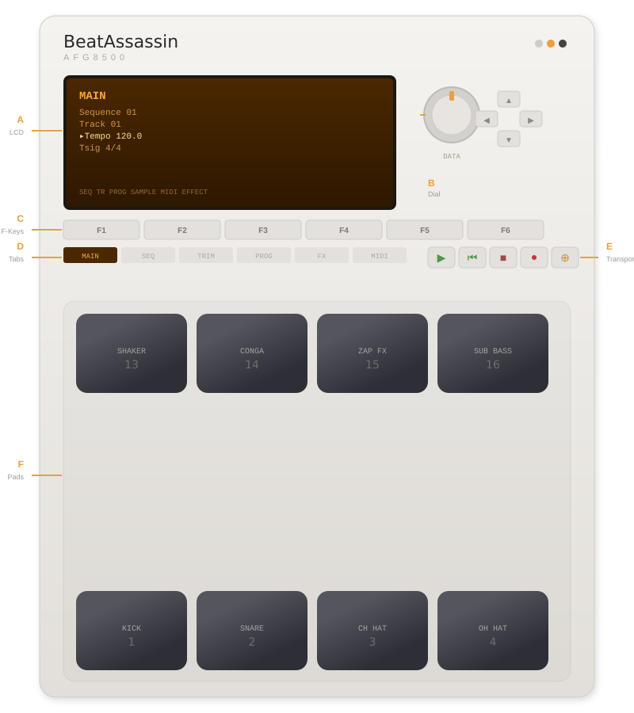
Label | Area | Purpose
A | LCD Screen | Displays menus, parameters, sequencer grid, and pad info
B | Data Wheel | Drag up/down to change the selected parameter value
C | F-Keys (F1–F6) | Quick access to functions shown at the bottom of the LCD
D | Screen Tabs | Tap to switch between MAIN, SEQ, TRIM, PROG, FX, and MIDI screens
E | Transport | Play, Stop, Record, and Overdub controls for the sequencer
F | Pad Grid | 16 velocity-sensitive pads for triggering drum sounds

2. Playing the Pads
The 16 pads fill the bottom half of the screen. Each pad triggers a different drum sound. Pad 1 (bottom-left) is Kick, Pad 2 is Snare, and so on. The sound name and number are printed on each pad.

Pad Layout
Row | Pads | Sounds
Top | 13, 14, 15, 16 | Shaker, Conga, Zap FX, Sub Bass
Second | 9, 10, 11, 12 | Rimshot, Cowbell, Ride, Crash
Third | 5, 6, 7, 8 | Clap, Tom Lo, Tom Mid, Tom Hi
Bottom | 1, 2, 3, 4 | Kick, Snare, Closed Hat, Open Hat

Velocity Sensitivity
The pads respond to how you play them. Quick, repeated taps register as softer ghost notes at lower velocity, while deliberate single taps come through at full velocity. On devices with pressure-sensitive screens, the actual force of your touch is used instead.
Velocity affects two things: the volume of the sound, and the brightness of the pad glow. This gives you immediate visual and audio feedback.
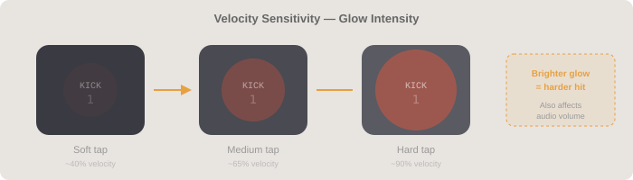
TIP: To play ghost notes on a hi-hat, rapidly double-tap the pad. The second hit will sound softer and glow dimmer.

Pad Banks
The BeatAssassin has four pad banks: A, B, C, and D. Each bank is a complete sound program with its own parameter settings and its own sequencer pattern. The bank buttons sit just above the pad grid.
Bank | Preset Name | Character
A | STANDARD | Balanced default kit with neutral settings
B | HEAVY | Boosted volumes, detuned kicks, wide stereo panning
C | TIGHT | Short decays, slightly sharp tuning, punchy feel
D | WIDE | Extreme stereo spread, long sustain
TIP: Switching banks while the sequencer is playing will stop playback. Each bank remembers its own sequence independently.

3. LCD Screen Navigation
The orange LCD screen is the brain of the AFG8500. It has six screens you can access via the screen tabs or F-keys. The currently selected parameter is highlighted in bright amber, and you can change its value with the data wheel or the left/right cursor arrows.

Navigating Parameters
Move between fields: Use the ▲ Up and ▼ Down cursor buttons to move the selection highlight between parameters on the current screen.
Change a value: Drag the Data Wheel up or down, or tap the ◀ Left / ▶ Right cursor arrows. Each nudge changes the value by one step.
Switch screens: Tap any of the six screen tabs (MAIN, SEQ, TRIM, PROG, FX, MIDI), or press the F-keys which map to the labels at the bottom of the LCD.

Screen Reference
Screen | What It Does
MAIN | Shows the current sequence number, track, tempo (30–300 BPM), and time signature. This is your home base.
SEQ | The step sequencer. View and edit patterns per-sound, set bars (1–8), quantize resolution, swing amount, and metronome on/off.
TRIM | Sample trim controls: start point, end point, and loop mode. (Visual reference for future sample features.)
PROG | Per-pad sound editing. Adjust volume, pan, tune, and decay for whichever pad you last hit.
EFFECT | Effects processor: choose from Reverb, Delay, Chorus, Flanger, or Phaser with level and two parameter knobs.
MIDI | MIDI channel, sync source, clock output, and soft-thru routing settings.

4. Using the Sequencer
The sequencer is what turns the BeatAssassin from a simple pad instrument into a full drum machine. It records your pad hits onto a looping grid, then plays them back in time. Navigate to the SEQ screen to see the step grid.

The Step Grid
The step grid shows one sound at a time. Use the left/right arrows at the top of the SEQ screen to cycle through all 16 sounds. Each small square represents one 16th note. Lit squares have a hit; empty squares are silent.
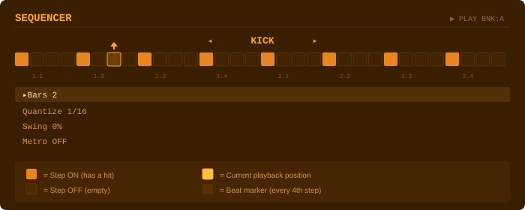
You can tap any step to toggle it on or off manually, even while the sequence is playing. This is great for programming precise patterns.

Transport Controls
The five transport buttons sit to the right of the screen tabs:
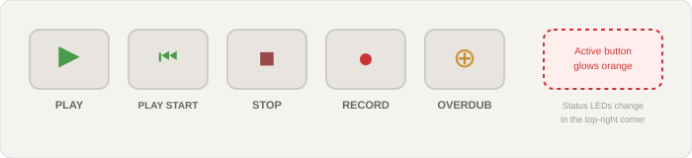
Button | Symbol | Function
Play | ▶ | Start playback from the current position
Play Start | ⏮ | Restart playback from beat 1
Stop | ■ | Stop playback and reset to the beginning
Record | ● | Clear the sequence and start fresh recording. Hit pads in real time as the loop plays.
Overdub | ⊕ | Layer new hits on top of the existing pattern without erasing anything. Toggle on/off.
TIP: The three LED dots in the top-right corner of the device show status: green = playing, red = recording, amber = overdub.

Recording a Beat
Here is the step-by-step workflow for recording your first pattern:
- Set your tempo on the MAIN screen (default is 120 BPM).
- Set the number of bars on the SEQ screen (default is 2 bars = 32 steps).
- Press the Record button (●). The previous sequence is cleared and the loop starts.
- Tap pads in time with the beat. Your hits are quantized to the grid based on the Quantize setting (1/16 by default).
- Press Stop (■) when finished, or switch to Overdub (⊕) to keep adding layers.
- Press Play (▶) to hear your pattern loop.

Swing and Metronome
Swing delays every other 16th note slightly, giving your pattern a shuffled, groovy feel. Set it from 0% (straight) to 75% (heavy shuffle) on the SEQ screen.
The Metronome adds a click track during playback, with an accented click on each downbeat (the first beat of each bar). Turn it ON while recording to stay in time, then turn it OFF for the final playback.

5. Editing Pad Sounds
Every pad has four parameters you can tweak to shape its sound. Navigate to the PROG screen to access them. The LCD shows visual meter bars for instant feedback.
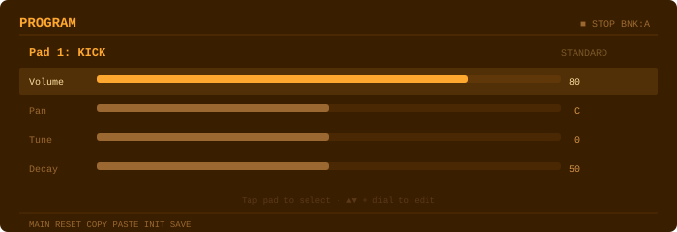

Parameters
Parameter | Range | What It Does
Volume | 0 – 100 | Controls the loudness of the pad. Pads visually dim when their volume is lowered.
Pan | L50 – C – R50 | Moves the sound in the stereo field. L = left speaker, R = right speaker, C = center.
Tune | -12 – +12 | Shifts the pitch in semitones. -12 is one octave down, +12 is one octave up. Pads with non-zero tuning show a small badge.
Decay | 0 – 100 | How long the sound rings out. Low values make tight, clipped hits. High values let sounds sustain.

Editing Workflow
1. Tap a pad to select it. The PROG screen updates to show that pad’s name and current settings.
2. Use ▲▼ arrows to highlight Volume, Pan, Tune, or Decay.
3. Drag the data wheel or use ◀▶ arrows to adjust the value. The meter bar updates in real time.
4. Tap the pad again to audition the change immediately.

Copy, Paste, and Reset
The F-key bar at the bottom of the PROG screen gives you quick editing shortcuts:
F-Key | Action | Description
F2 | RESET | Restores the selected pad to factory defaults (Vol 80, Pan C, Tune 0, Decay 50)
F3 | COPY | Copies the selected pad’s four parameters to the clipboard
F4 | PASTE | Applies the clipboard settings to the currently selected pad
F5 | INIT | Resets the entire current bank (all 16 pads) to factory defaults
TIP: Use Copy/Paste to quickly apply the same settings across multiple pads. For example, copy the tight decay of your snare to all three toms.

6. Tips and Tricks

Building a Beat From Scratch
Start simple. Record just a kick pattern on beat 1 and beat 3. Then overdub a snare on beats 2 and 4. Add a closed hi-hat on every 8th note. From there, embellish with claps, shakers, and cymbal hits. Building in layers is the classic MPC workflow.

Using Banks Creatively
Each bank has its own sound settings AND its own sequence. Try making Bank A your main verse beat, Bank B a fill or variation, Bank C a breakdown section, and Bank D a buildup. Even though there is no song-chaining mode, you can manually switch banks while performing live.

Getting Groovy with Swing
Start with a swing of around 25–35% for a subtle shuffle. This works particularly well with hi-hat patterns. Heavier swing (50%+) gives more of a hip-hop or neo-soul feel.

Stereo Imaging
Use the Pan parameter in the PROG screen to spread your sounds across the stereo field. A good starting point: keep kick and snare centered, pan hi-hats slightly right, pan shakers slightly left, and spread toms across the field from left to right.

Performance Tip
The app includes haptic feedback (vibration) on phones that support it. You will feel a subtle pulse when you hit a pad, a lighter tap on buttons, and a double-pulse on transport controls. This helps confirm your inputs without looking at the screen.

7. Quick Reference Card
Keep this page handy while learning the BeatAssassin.
Sound Map (Bank A Defaults)
Pad # | Sound | Pad # | Sound
1 | Kick | 9 | Rimshot
2 | Snare | 10 | Cowbell
3 | Closed Hi-Hat | 11 | Ride
4 | Open Hi-Hat | 12 | Crash
5 | Clap | 13 | Shaker
6 | Tom Low | 14 | Conga
7 | Tom Mid | 15 | Zap FX
8 | Tom High | 16 | Sub Bass
Keyboard Shortcuts (Quick Actions)
Action | How
Change tempo | Go to MAIN screen, select Tempo, drag the data wheel
Record a pattern | Press ● Record, tap pads in time, press ■ Stop
Add to existing pattern | Press ⊕ Overdub while playing
Edit a step manually | Go to SEQ screen, tap any step square to toggle
Change a pad’s sound | Go to PROG screen, tap the pad, adjust Volume/Pan/Tune/Decay
Clear the pattern | Press ERASE or use F2 (CLEAR) on the SEQ screen
Switch sound kits | Tap Bank A/B/C/D buttons above the pad grid
Turn on metronome | Go to SEQ screen, set Metro to ON
BeatAssassin AFG8500 · v2.1.0 · 16-Voice Digital Drum Machine

